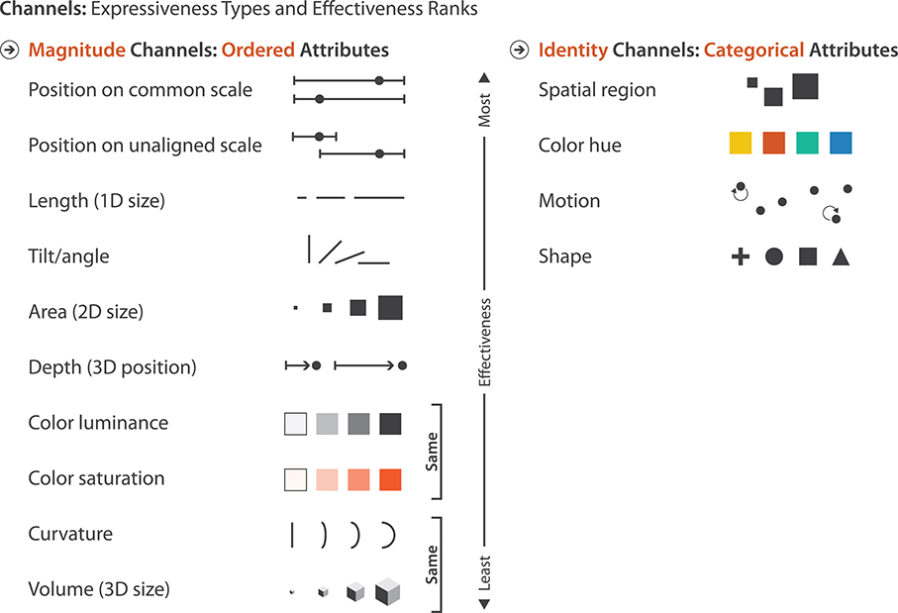

Slide 5

Some pertain to spatial position, including aligned planar position, unaligned planar position, depth (3D position), and spatial region. Others pertain to colour, which has three distinct dimensions: hue, saturation, and luminance. There are three size channels, one for each added dimension: length is 1D size, area is 2D size, and volume is 3D size. The motion-oriented channels include the motion pattern, for instance, oscillating circles versus straight jumps, the direction of motion, and the velocity. Angle is also a channel, sometimes called tilt. Curvature is also a visual channel. Shape is a complex phenomenon, but it is treated as a channel in this framework.

Slide 10

Graphic of accuracy perception

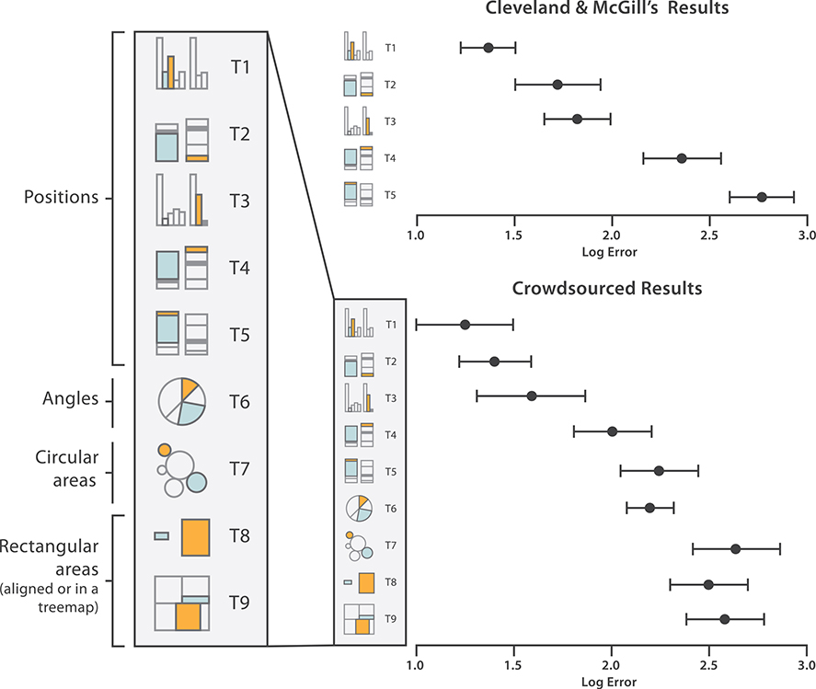

Cleveland and McGill (1984) followed by Heer and Bostock with crowd-sourced results.

Slide 12

The figure shows pairs of visual channels at four points along this continuum. On the left is a pair of channels that are completely separable: position and hue. We can easily see that the points fall into two categories for spatial position, left and right. We can also separately attend to their hue and distinguish the red from the blue. It is easy to see that roughly half the points fall into each of these categories for each of the two channels.

Next is an example of interference between channels, showing that size is not fully separable from colour hue. We can easily distinguish the large half from the small half, but within the small half discriminating between the two colours is much more difficult. Size interacts with many visual channels, including shape.

The third example shows an integral pair. Encoding one variable with horizontal size and another with vertical size is ineffective because what we directly perceive is the planar size of the circles, namely, their area. We cannot easily distinguish groupings of wide from narrow, and short from tall. Rather, the most obvious perceptual grouping is into three sets: small, medium, and large. The medium category includes the horizontally flattened as well as the vertically flattened.

The far right graph in the figure shows the most inseparable channel pair, where the red and green channels of the RGB colour space are used. These channels are not perceived separately, but integrated into a combined perception of colour. While we can tell that there are four colours, even with intensive cognitive effort it is very difficult to try to recover the original information about high and low values for each axis. The RGB colour system used to specify information to computers is a very different model than the colour processing systems of our perceptual system, so the three channels are not perceptually separable.

Slide 13

A red circle does not pop out automatically from a sea of objects that can be red or blue and circles or squares: the speed of finding the red circle is much faster in Figure (e) with few distracting objects than in Figure (f) with many distractors. The red circle can only be detected with **serial search**: checking each item, one by one. The amount of time it takes to find the target depends linearly on the number of distractor objects.

Most pairs of channels do not support popout, but a few pairs do: one example is space and colour, and another is motion and shape. Popout is definitely not possible with three or more channels. As a general rule, vis designers should only count on using popout for a single channel at a time.

Slide 14

Other channels that support popout include: tilt, size, shape, proximity, and even shadow direction. Many other channels support popout, including several different kinds of motion such as flicker, motion direction, and motion velocity. All of the major channels commonly used in visual encoding that are shown in the Figure do support popout individually, although not in combination with each other. However, a small number of potential channels do not support popout. Figure (f) shows that parallelism is not preattentively detected; the exactly parallel pair of lines does not pop out from the slightly angled pairs but requires serial search to detect.

Slide 16

The length judgement in Figure (a) is difficult to make with unaligned and unframed bars. It is easier with framing, as in Figure (b), or alignment, as in Figure (c), so that the bars can be judged against a common scale. When making a judgement without a common scale, the only information is the length of the bars themselves. Placing a common frame around the bars provides another way to estimate magnitude: we can check the length of the unfilled bar. Bar B is only about 15% longer than Bar A, approaching the range where length differences are difficult to judge. But the unfilled part of the frame for Bar B is about 50% smaller than the one for Bar A, an easily discriminable difference. Aligning the bars achieves the same effect without the use of a frame.